The Impact of AI Policies and Education For Future Market
-Simran Anjana Rajput
Introduction:
Global economies are experiencing rapid shifts due to artificial intelligence (AI), which has an impact on how governments construct education systems, invest in research, and create laws. Countries have implemented AI-specific policies to improve workforce preparedness, digital infrastructure, and ethical AI governance given that they recognize the technology's revolutionary potential. Simultaneously, educational systems are evolving to better prepare students for a future led by AI, especially by expanding access to technology, STEM education, and digital literacy.
The OECD AI Policy Observatory and UN Sustainable Development Goals (SDG) Indicators datasets are made freely available for this project. The SDG dataset sheds light on educational variables like gender parity, ICT proficiency, literacy rates, and school enrollment levels, whereas the OECD dataset documents national AI initiatives and policy areas across nations. Through the integration and analysis of these statistics, the initiative seeks to identify trends and connections between the implementation of AI policies and educational results.
Methodology:
With the objective to examine the correlation between AI policy and educational performance across numerous nations, this study combines two reliable datasets. Data extraction, cleaning, transformation, and visualization using Power BI are all part of the technique.
1. Data Sources
a. OECD.AI Policy Observatory
- This dataset includes detailed records of national AI policies from multiple countries, categorized by deployment year, policy area (e.g., education, workforce, ethics), and implementation status.
- Data was collected from the OECD AI Policy Database:
🔗 https://oecd.ai/en/dashboards/policy-database
b. UN Sustainable Development Goals (SDG) – Education Indicators
- The SDG dataset focuses on global education metrics, including literacy rates, enrollment, ICT skills, and gender-specific completion rates at different education levels.
- Data sourced from the UN SDG Global Database:
🔗 https://unstats.un.org/sdgs/indicators/database/
2. Importing Data
Using the Power Query Editor, CSV files from the SDG and OECD sources were imported into Power BI.
Data Cleaning
Duplicate or null records were eliminated. Standardized Country names to guarantee uniform merging. Filtered pertinent columns, including gender, indicator labels, deployment year, and policy kind.
Transformation of Data
Generated columns for gender-based breakdowns of education metrics, "AI Policy Count per Country," and "Distinct Policy Areas." Combined datasets with shared dimensions (e.g., Year, Country).
Enrichment of Data
To facilitate geographic analysis, custom columns such as Region were added (via SDG_REGION.csv). Created derivative fields for diversity, policy volume, and metrics measuring educational performance.
Visualization
To address the study questions, 12 visualizations were created, including dashboards, parameter-driven filters, dynamic charts, maps, and drilldowns.
Parameters added:
Countofpolicies = COUNT('oecd-ai-all-ai-policies'[AI Policy Area(s)])
CountryYear = CONCATENATE('oecd-ai-all-ai-policies'[Country],'oecd-ai-all-ai-policies'[Deployment year])
Gender = IF(CONTAINSSTRING(LOWER(SDG_LABEL[INDICATOR_LABEL_EN]), "male"), "Male", "Female")
Countryname_en = CONCATENATE(SDG_DATA_NATIONAL[COUNTRY_NAME_EN],SDG_DATA_NATIONAL[YEAR])
Research Question:

1. How are AI principles distributed and deployed across different countries, and what regional trends can be observed in policy focus?”

According to the graph, nations in North America and Europe embrace more AI principles and cover a greater range of topics than nations in other regions, including accountability, transparency, and fairness. Limited adoption in certain nations, which concentrate on just one or two principles, suggests variations in the breadth of policies and regional objectives.
The bubble graphic does an excellent task of illustrating the variety and quantity of concepts that each nation has adopted. It provides clear, concise presentations of regional and national trends. By emphasizing the diversity and breadth of AI policy acceptance around the world, the visual structure directly addresses the research issue.

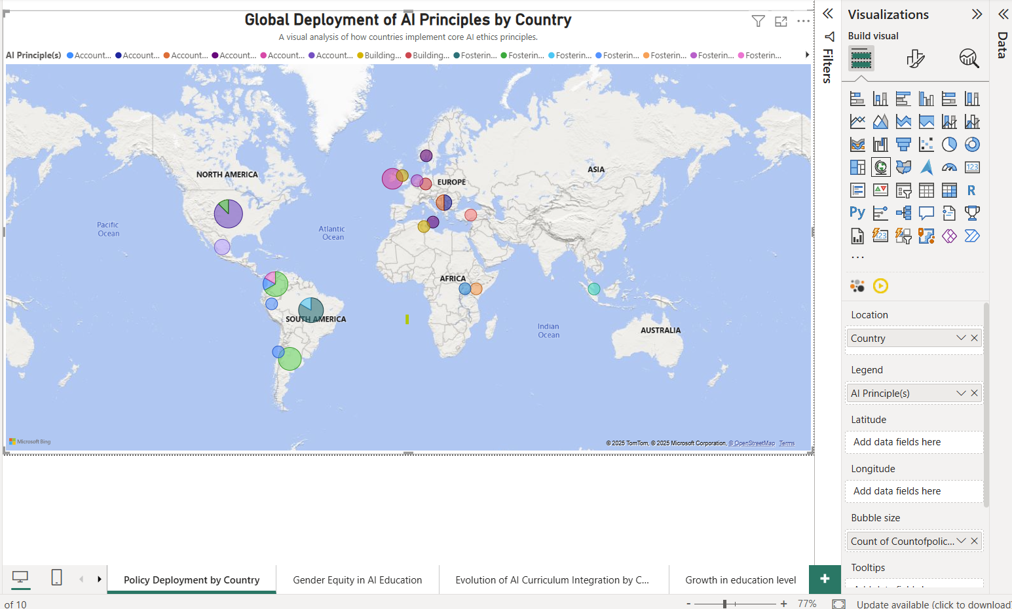

2.How has the development of AI policy areas over time aligned with changes in parental education levels globally?

The chart indicates a consistent rise in reported parental education levels and AI policy development between 2015 and 2021. This shows that there may be a connection between the growing emphasis on AI policy and education around the world, suggesting that these two trends may be developing simultaneously.
Two trends are shown side by side in the dual-axis line chart without any clutter. By making it simple to compare changes in parental education levels and AI policy activity over the same time period, it successfully supports the research question. Everything displayed is immediately applicable and comprehensible.
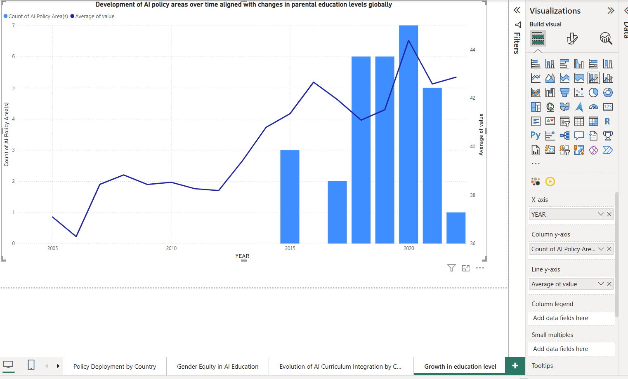

3. How has the deployment of AI policies evolved over time across different regions?

According to the visualization, the number of nations implementing AI-related education increased steadily between 2015 and 2021. This trend was driven by early and persistent attempts to integrate AI into school curricula in regions like Europe and East Asia. A combination of STEM-based AI courses, AI ethics courses, and AI-specific courses have been introduced in these areas.
Africa and South America, on the other hand, exhibit slower and later adoption. Despite some recent advancements, there are still fewer AI education programs in these regions than in other regions of the world.

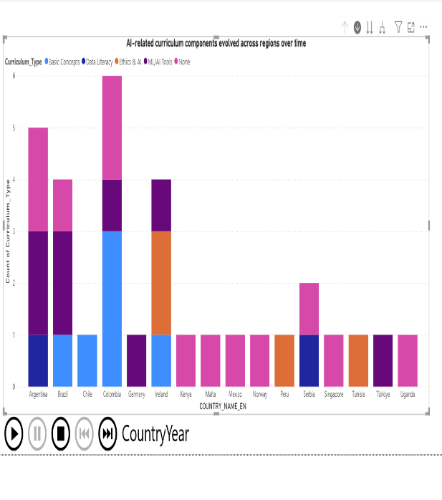
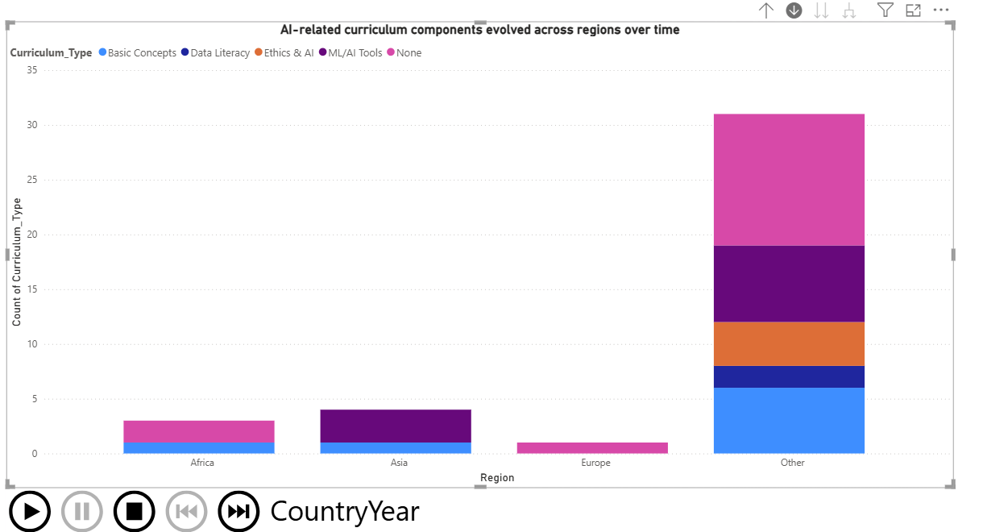

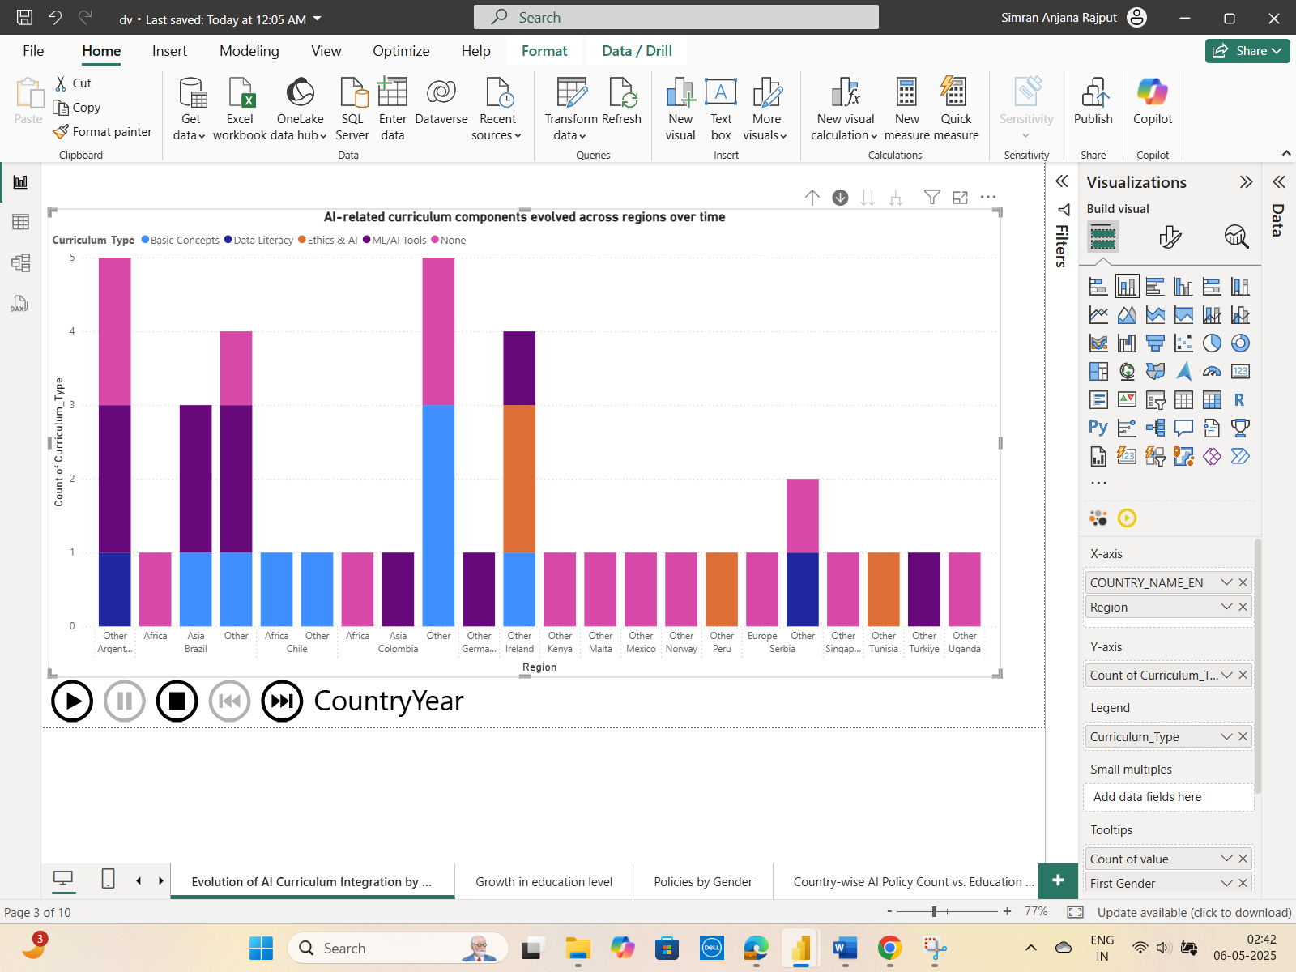

4. What are the main categories of AI-related education policies, and how frequently does each type occur?

The pie chart illustrates the division of AI-related educational policies into three primary groups:
The most prevalent policies, accounting for 42.22% of all policies recorded, are those pertaining to curriculum reform and public awareness. This demonstrates a strong global emphasis on educating the public about AI and incorporating AI-related content into school curricula.
The remaining 15.56% of policies are related to teacher training, indicating that although teacher preparation is recognized, it is given less policy attention than the other areas.

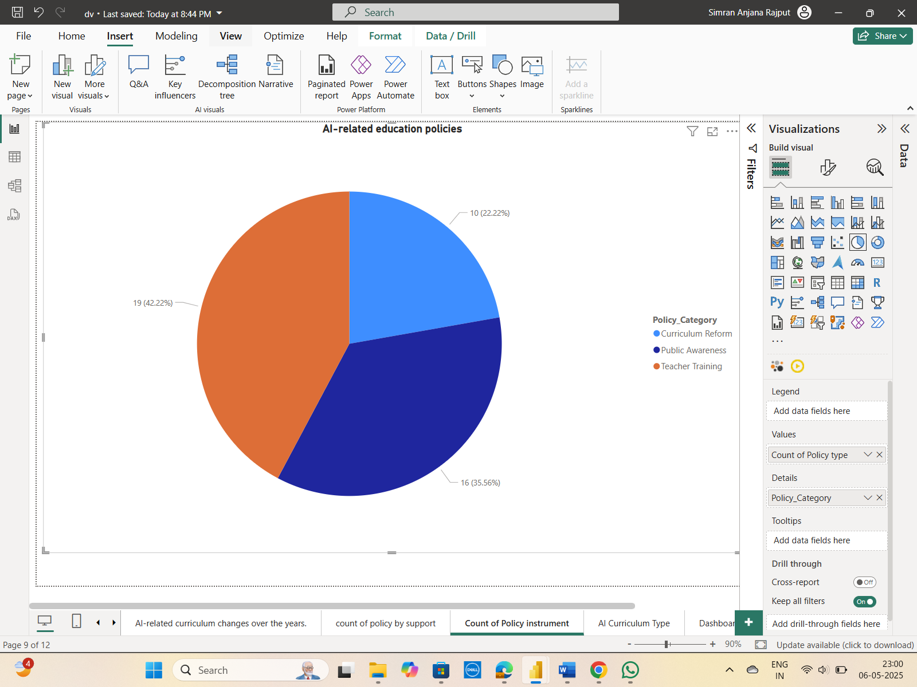

5. Do broader and more numerous AI policies lead to better education outcomes across curriculum types?

The graphic demonstrates a clear correlation between a nation's educational results and the quantity and diversity of its AI policies. Here, parental education is used as a proxy for overall educational quality, and countries that have adopted a broader variety of AI curriculum types including topics like ethics, data literacy, machine learning tools, and basic AI concepts tend to have higher levels of parental education.
The graph demonstrates how countries with AI policies that focus on broad areas like public governance, the digital economy, and health continuously have better educational results. Conversely, nations with a more limited focus on AI policy


6. How has gender equity in lower secondary education completion rates evolved over time at the national level?
The graph indicates that over time, completion rates have risen consistently for both males and females. Nonetheless, depending on the nation and the year, one gender may occasionally lead the other, and gender disparities continue to be apparent for a number of years. In general, the gap seems to have closed in recent years, suggesting that gender equity has been gradually achieved.
When comparing the annual completion rates of men and women, the clustered bar chart works well. It keeps things simple, only shows the important factors (gender, time, and completion rate), and facilitates straightforward analysis of patterns and differences in educational equity.
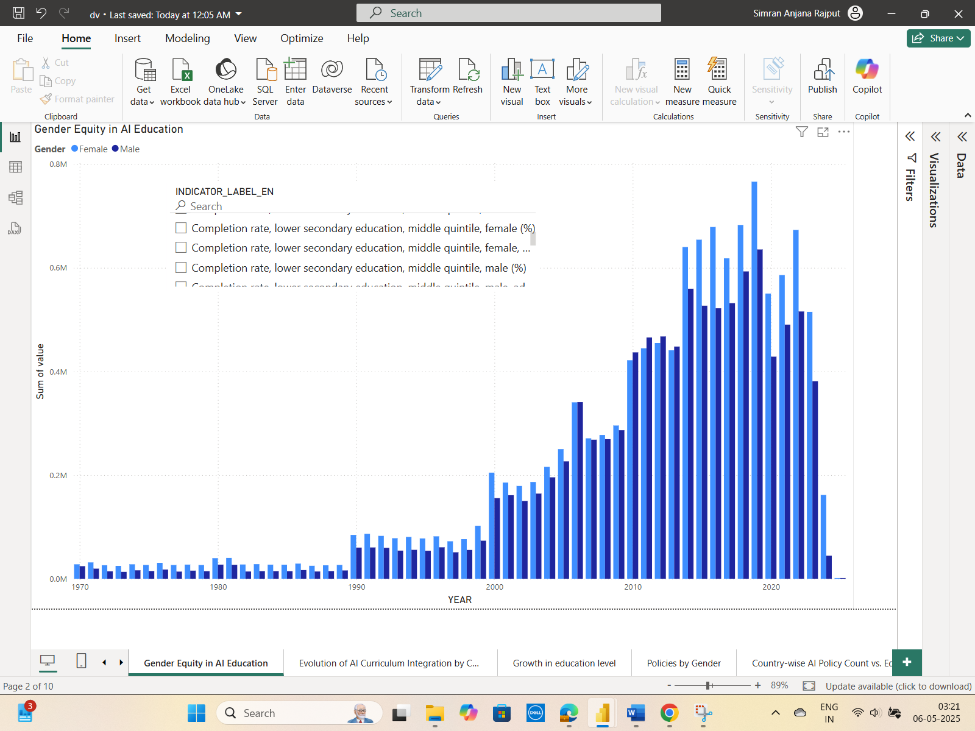

7. How does AI policy support influence the distribution of curriculum-related policy categories across countries?

The chart indicates that while curriculum reform shows less AI-related activity, policies related to teacher preparation and public awareness are the most frequently supported areas of AI. This suggests that while general education strategies are giving AI more attention, core curricula are still not fully integrating AI.
The clustered column chart effectively compares policy areas based on AI support. It provides a clear, side-by-side view of how different curriculum types align with AI policies, omitting unnecessary information, making it easy to spot trends and gaps in AI-related educational initiatives.

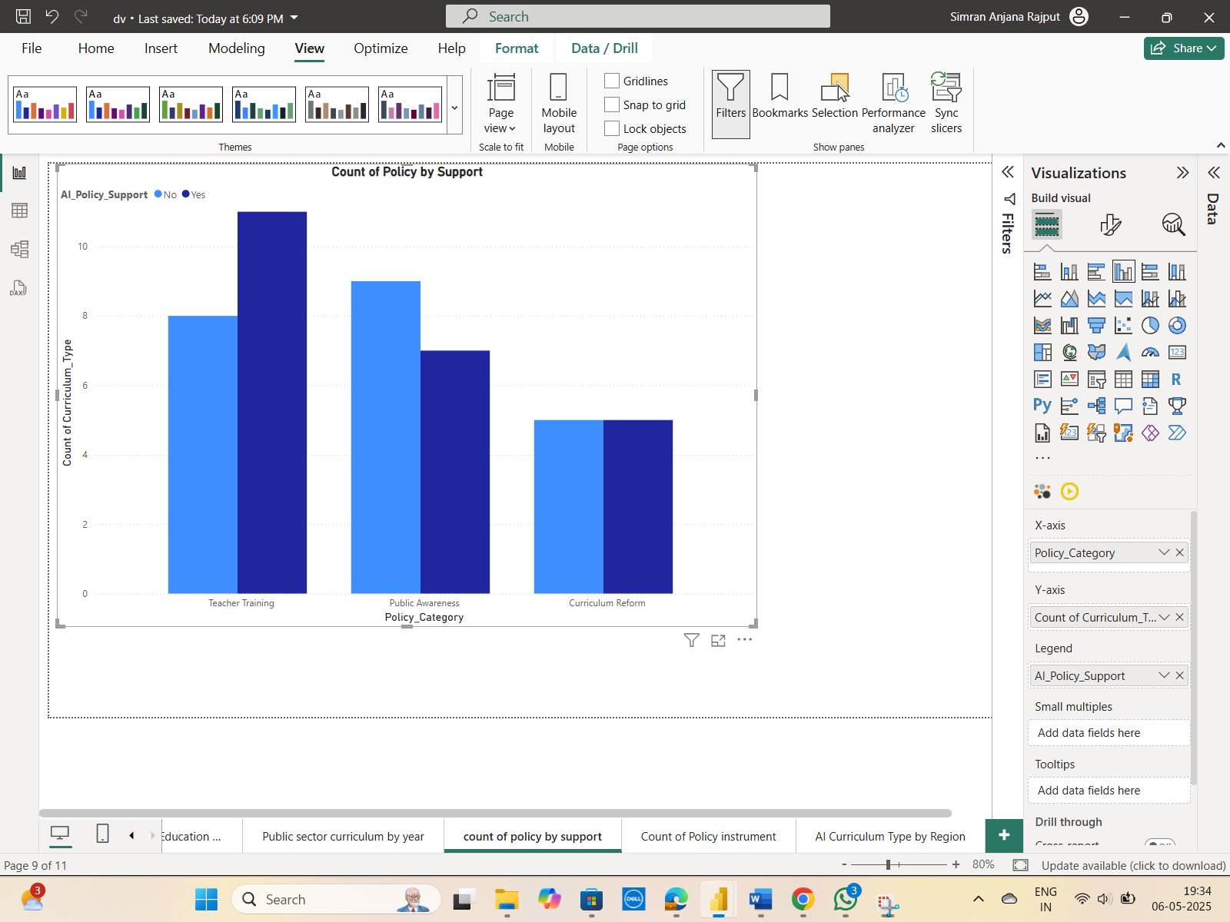

8. What AI policy areas receive the most focus when filtered by gender, and how are female-related dimensions represented across different policy categories?
The graphic demonstrates that the fields of public governance, education, and social welfare are where AI policies that target issues unique to women are most frequently found. The greatest number of policy tools that specifically address or support women's programs and priorities are found in these areas.
On the other hand, there are significantly fewer AI policy tools targeted at women in fields like industry, entrepreneurship, and the digital economy. This suggests a significant disparity in the representation of women in fields essential to economic development and technological innovation.
Women are still underrepresented in emerging and high-tech policy areas, despite the fact that social systems and education policies have strong gender representation, according to the chart. This suggests that AI planning needs to be more inclusive, particularly in industries that will influence the economy in the future.
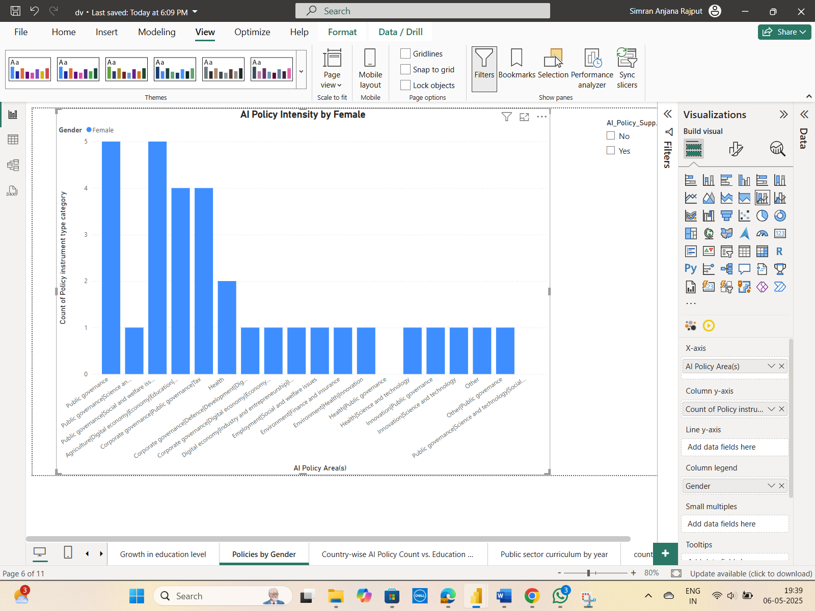
9. How do different regions vary in integrating AI curriculum components into education systems?
The stacked column chart demonstrates that many nations, particularly those in the "Other" region category (which primarily consists of non-Western nations), do not incorporate any AI curriculum elements at all. On the other hand, some areas—like Europe and some parts of Asia—are more likely to have included ML/AI tools and fundamental AI ideas into their curricula.
This implies that even though people are becoming more aware of AI, many nations are still implementing AI education in its early stages. Globally, efforts are not uniform, with some areas adopting AI curriculum components more aggressively than others.
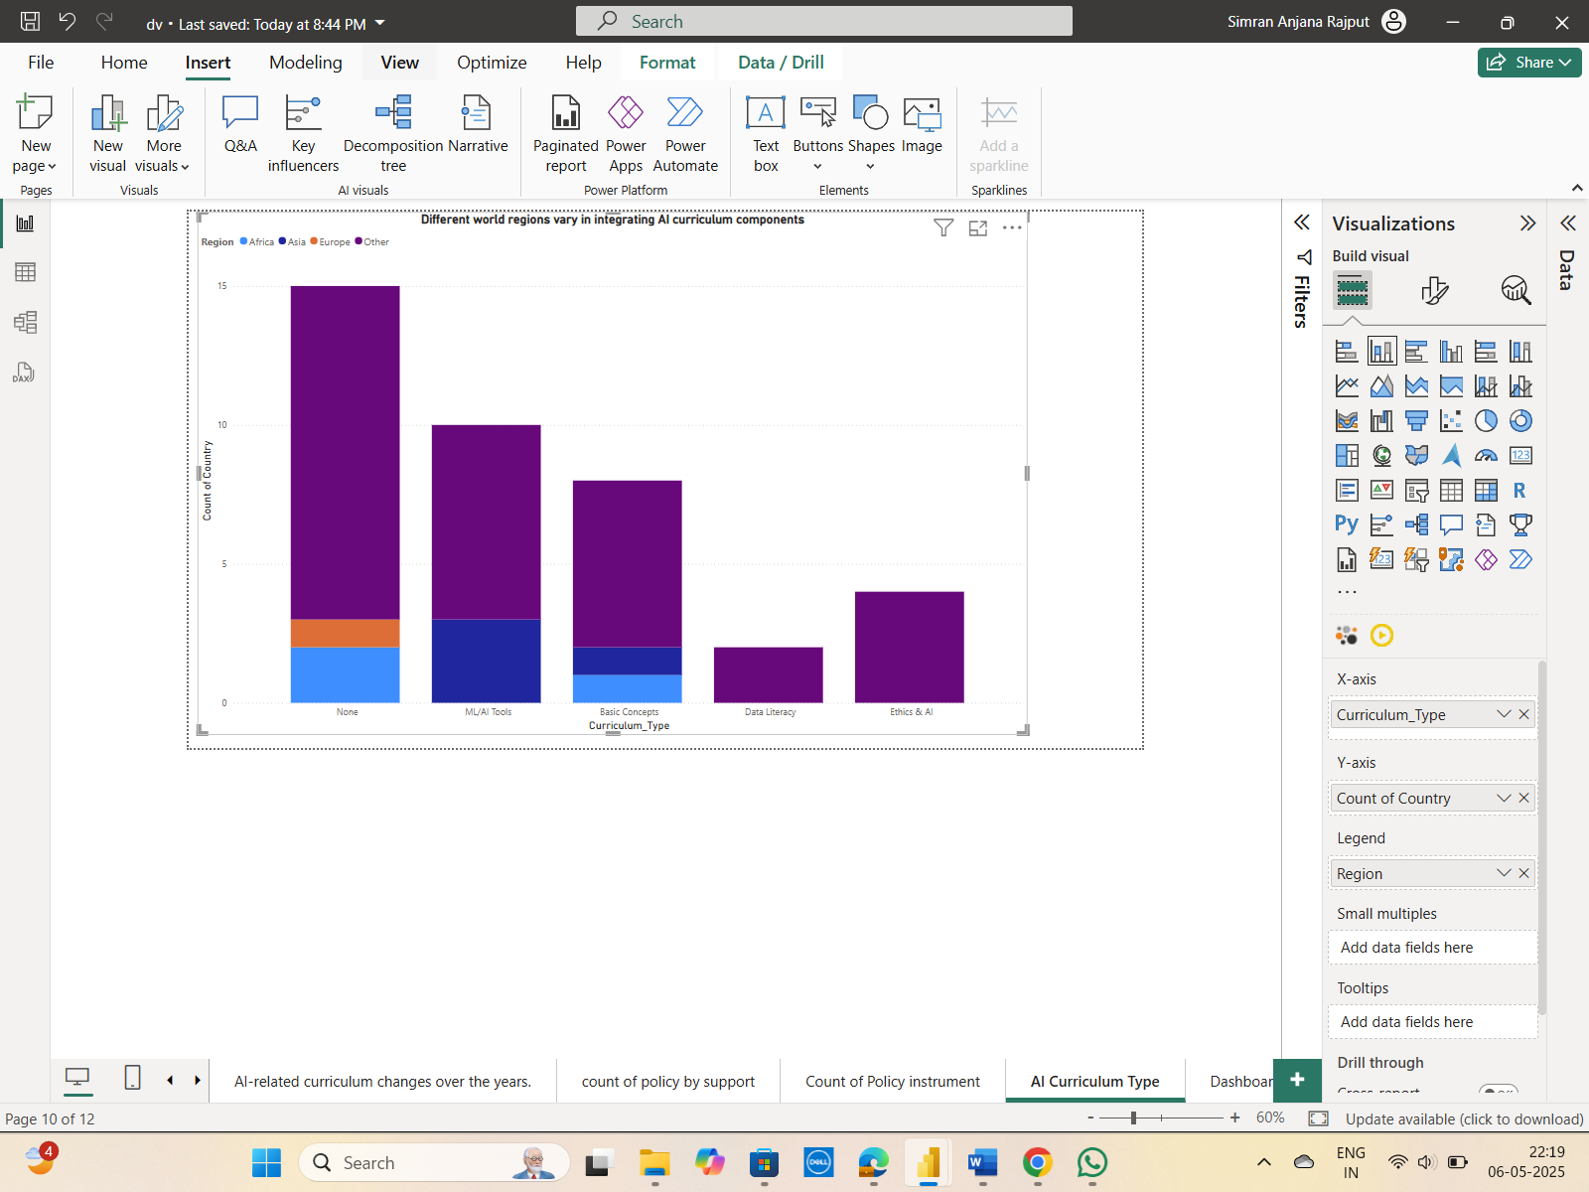
10. How have AI-related curriculum changes evolved over the years?
The frequency of curriculum modifications pertaining to AI in various years is displayed in the pie chart. It makes it simple to determine which years saw the most and least activity.
With 18.75% of all recorded changes occurring in 2016 and 2018, these two years stand out as the most active. Efforts to update or include AI topics in school curricula have clearly increased in recent years.
High activity was also seen in 2015 and 2017, with each year accounting for 15.63% of the changes. With percentages ranging from 3.13% to 9.38%, smaller sections of the chart are taken by 2019, 2020, 2022, and 2023.
The 2010 share, which is the smallest at 1.56%, illustrates how uncommon AI curriculum modifications were in prior years.
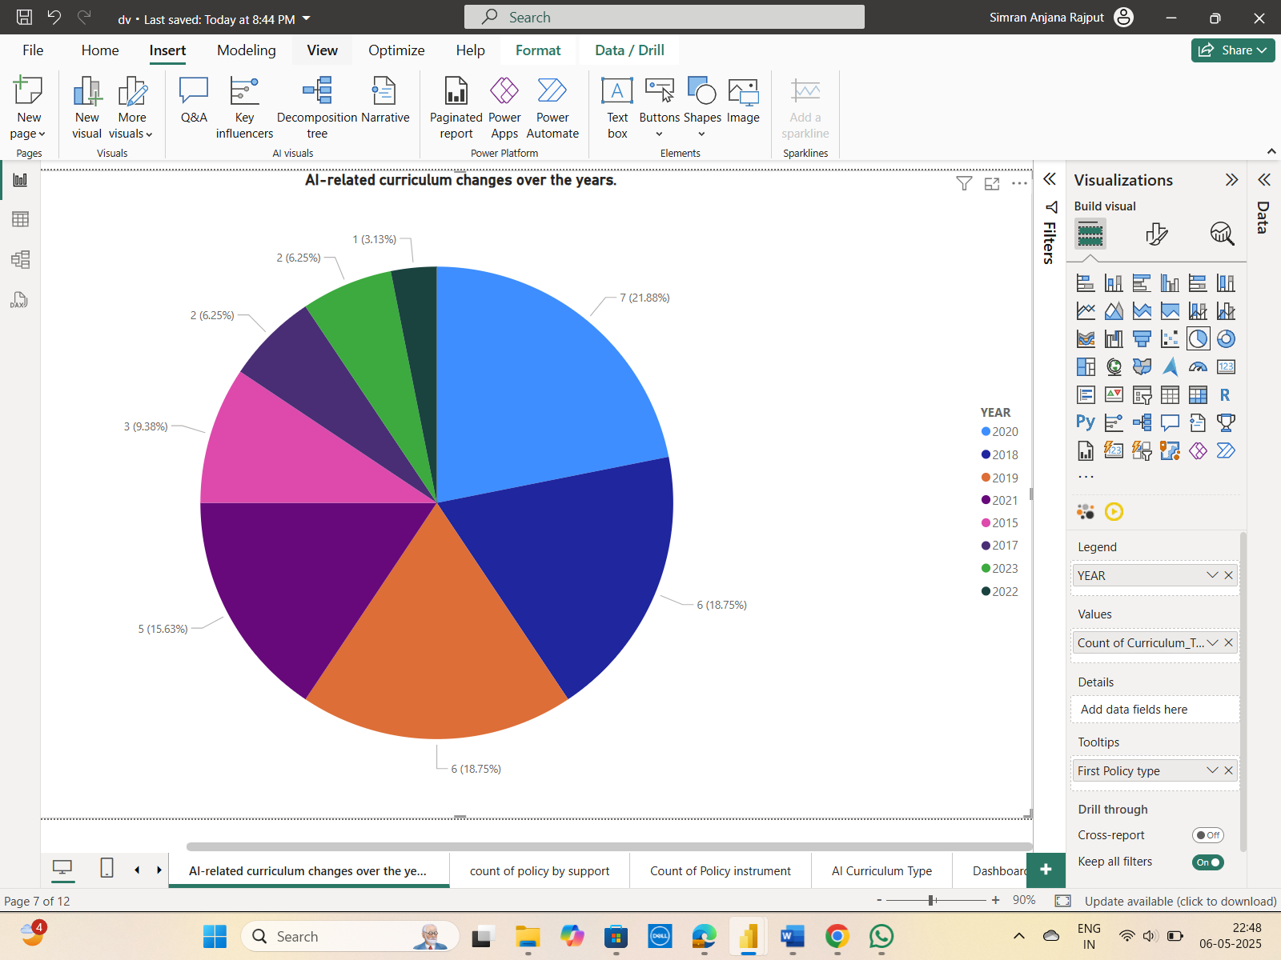
Dashboards:
1: AI Policy & Governance Readiness Aim:
To assess how countries are approaching the governance of AI through formal policies, ethical principles, and strategic implementation supports.
According to the charts, curriculum reform trails behind teacher training and public awareness as the most prevalent forms of AI policies. This implies that nations should prioritize short-term capacity-building and awareness-raising over long-term curriculum modifications. The world map illustrates how AI concepts are being adopted globally, with North America and Europe leading the way.
The visuals are powerful: the map provides geographical context without being overly complicated, the clustered bar chart displays support levels, and the pie chart displays policy distribution by type.

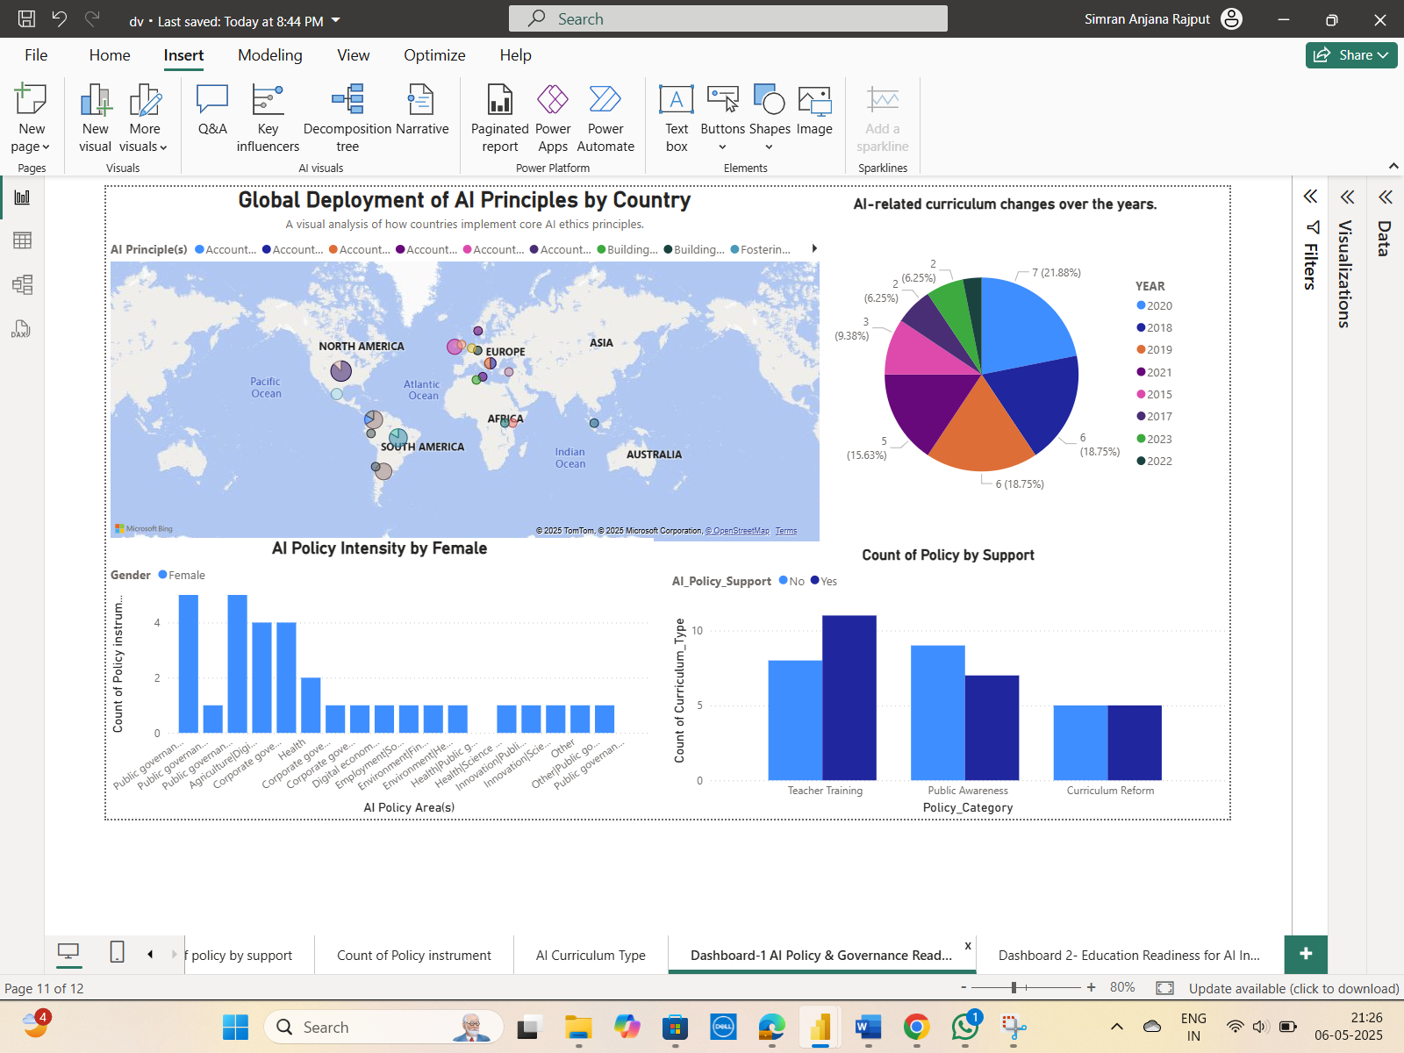

2: AI-Driven Education Reform Aim:
To explore how education systems are adapting to support AI transformation, including curriculum changes, literacy development, and equity.
The bar charts demonstrate that many nations, particularly those in Asia and Africa, still lack a formal AI curriculum. More people are using ML/AI tools and fundamental ideas than subjects like data literacy or ethics and AI.
AI policies have grown since 2015, particularly in a variety of policy areas, according to a time-based chart. Although female participation is increasing, gender equity data shows that men predominate in AI education settings.
These graphics are appropriate: the stacked bar chart clearly delineates the different types of curricula by region, and the combination of lines and bars facilitates the link between educational change and policy growth.

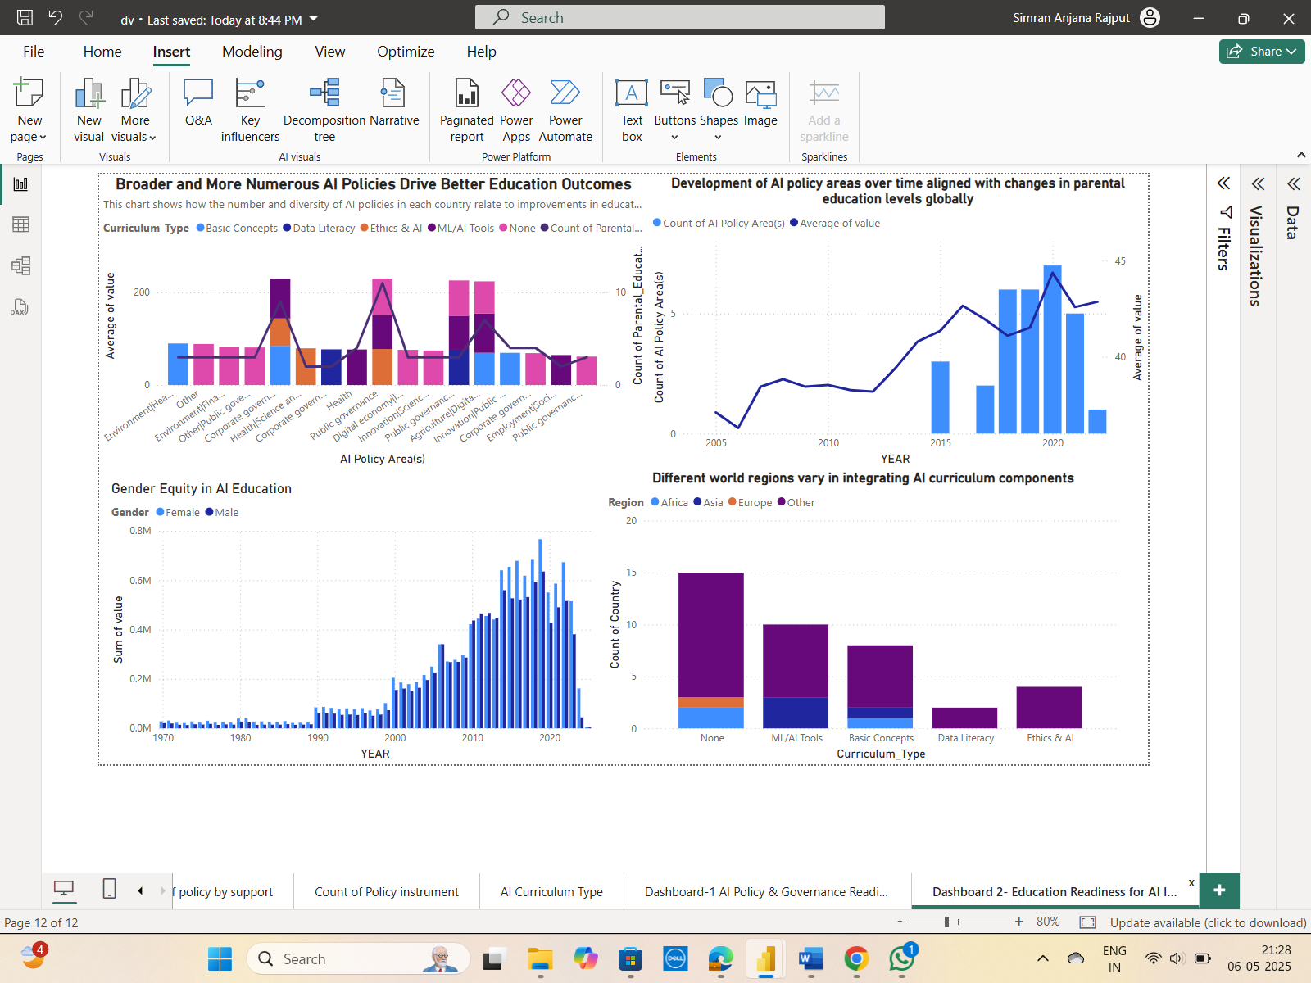

Conclusion:
All things considered, the dashboards show that although global efforts to implement AI policies are increasing, they differ in terms of regional adoption and curriculum integration. Curriculum reforms are given less priority than short-term measures like awareness and training. Planning for AI education still requires wider regional inclusion and balanced gender participation.
Identification of additional research questions:
- How does gender equity in AI education evolve over decades, and what policies influence this trend?
- Which curriculum types (e.g., ML/AI tools, Ethics & AI) are most commonly integrated in regions with high AI policy diversity?
- What is the relationship between AI policy diversity and improvements in national education systems?
- How do basic AI concepts in education differ in implementation between developed and developing regions?

